Osmanabadi Goat Breed Status Paper
Chanda Nimbkar
PI, Osmanabadi Field Unit, ICAR-AICRP Goat Improvement
Introduction
Osmanabadi is one of the most numerous breeds among the recognized goat breeds in Maharashtra State and in India. However, many people who rear these tall, prolific black coloured goats have no idea of the name ‘Osmanabadi’. They call them ‘deshi’. The earliest reference to the Osmanabadi is said to be in the book by Kaura (1952) who said that it was also known as the Deccani goat. These goats were supposed to have originated from a mixture of the goats of the plains.
Distribution
Acharya (1972), mentions only Latur, Tuljapur and Udgir taluks of Osmanabad district of Maharashtra under ‘distribution’ of Osmanabadi goats. The survey of Osmanabadi goats under the Network Project (Koratkar, 1999), however, considered Ahmednagar, Osmanabad and Solapur districts of Maharashtra (an area of about 14.2 lakh ha.) as the breeding or home tract of Osmanabadi goat. Osmanabadi goats are practically found in many more districts of Central and Western Maharashtra. Koratkar (1995) and Kumar (2007) have stated that the Osmanabadi breed has spread to other States like Karnataka, Andhra Pradesh and Madhya Pradesh.
Population and trends over time
According to the Breed Survey done under the 19th Livestock Census (DADF, 2013), there are 23 indigenous goat breeds recognised by the National Bureau of Animal Genetic Resources (NBAGR). Out of 135.04 million indigenous goats in the country, only 27% belong to these recognised pure breeds, 12% have more than 50% phenotypic similarity to recognised breeds and are called ‘graded’ while the majority or about 61% of the goats in the country are non-descript or so-called ‘deshi’. Osmanabadi goat breed population is 2.27% of the total number of goats in the country. 24.4% of the total adult female goats in Maharashtra are Osmanabadi (DADF, 2013). Osmanabadi is one of the 16 breeds in the country with more than 60% purebred animals, indicating the preference of the rearers for animals having typical breed characteristics. In 2012, the number of pure Osmanabadi goats (including all ages and sexes) in the country was estimated to be nearly 25 lakh with another 5.8 lakh graded Osmanabadi or Osmanabadi-type animals (DADF, 2013). Only three breeds have larger populations than the Osmanabadi; these are the Black Bengal, Marwari and Barbari. Jamnapari and Sirohi populations are similar to Osmanabadi but purebred Osmanabadi goats are larger in number than purebred goats of each of these two breeds.

Table 1: Numbers (in lakhs) of pure Osmanabadi goats in different States (DADF, 2007 and 2013)
 | Total pure Osmanabadi goats
State / Country | 2007* | 2012
 | Total goats | Males | Females | Total goats
Maharashtra | 12.8 | 4.4 | 15.4 | 19.8
Karnataka | 2.1 | 0.5 | 2.0 | 2.5
Andhra Pradesh | 0.6 | 0.5 | 2.0 | 2.5
India | 15.5 | 5.4 | 19.4 | 24.8
*Sex and age wise numbers of different goat breeds are not available for 2007.
The total number of goats in India has declined slightly by about 4% from 140.5 million in 2007 to 135.04 million in 2012. The number of Osmanabadi goats in India, however, appears to have increased by about 60% from 15.5 lakh to 24.8 lakh over these five years. Therefore the breed does not appear to be at risk. However, there seems to be an alarming 25% decline in the total number of goats in Maharashtra from 103.9 lakh in 2007 to 78.1 lakh in 2012. The number of Osmanabadi goats in Maharashtra, however, increased almost 54% from 12.8 lakh in 2007 to 19.8 lakh in 2012 (i.e. 10.8% per year on average).
Climate: In the breeding tract of the Osmanabadi breed, the highest temperature is recorded in April and May and the lowest in December and January. The highest temperature is 45⁰C while the mean maximum temperature is about 39⁰C. The lowest temperature recorded is 10.8⁰C while the mean minimum temperature is about 15⁰C. The lowest humidity of 39% was recorded in March while the highest 74% was recorded in August. The rainfall is low and erratic. The average annual rainfall is 500 mm but it can range from about 250 mm to 900 mm per year. The rain falls mainly between June and October. The highest average rainfall was recorded in September, indicating that this area receives heavier rain from the north-east or return monsoon. The area experiences severe droughts at least twice in every five years. The drought of 1972 was so far considered to be the worst drought but the current drought of 2015-16 is even worse.
Breed characteristics:
Colour: The common coat colour of Osmanabadi goats is black. The following are also common colour variants of Osmanabadi goats.
1)Black with white spots on ears (‘morkani’),
2)Black with white patches on the body such as under the stomach or on the tail or on the forehead
There is a strain called ‘Neknuri’ among Osmanabadi goats, which is found in taluka of district. Neknuri Osmanabadi have long, drooping ears and are faster growing and bigger in size than the ordinary Osmanabadi goats.
More than 90% females have horns. Polled bucks are also found occasionally.
Size: The weight of adult Osmanabadi bucks reared at the farm of Nimbkar Agricultural Research Institute is 45 to 50 kg. These bucks, however, keep growing in size as they grow older and 4-5 year old bucks may weight 54 to 56 kg. Adult bucks of the Neknuri strain of Osmanabadi purchased from the field at a young age and reared at NARI weigh around 60 kg.
The adult weight of Osmanabadi females is 35±5 kg.
Measurements:
Table: Least squares means of body measurements (cm) of Osmanabadi kids at birth and six months (No. of records at birth: 3000, at six months: 500)
Factor |  | Measurement at
Sex |  | Birth | 6 months
 |  | LSM±S.E. | LSM±S.E.
Males | Body Length | 26.8±0.1 | 51.0±0.7
 | Body Height | 31.1±0.2 | 59.3±0.7
 | Heart Girth | 31.1±0.2 | 56.7±0.8
Females | Body Length | 26.4±0.1 | 48.5±0.7
 | Body Height | 30.5±0.2 | 55.8±0.7
 | Heart Girth | 30.5±0.2 | 55.0±0.7
Flock structure:
There are few large flocks of more than 20 adult does. Less than 5% flocks have 11-20 does. Around 20% of the flocks have 6-10 does while 30 to 35% flocks have either 2-5 does or only one adult doe. The flocks larger than 10 does, keep a breeding buck in the flock. Almost half the male kids and 25% of the female kids in the 3-6 months age group are sold. Out of the remaining, more than 70% male kids and 40% female kids are sold in the 6-12 months age group.
Reproduction:
The average litter size of Osmanabadi goats is found to be 1.7. There are around 40% single births, 50% twins and 10% triplets and quadruplets. In exceptional cases, quintuplets have also been found. The age at first mating is 353±8 days. Age at first kidding is 506±18 days. The weight at first kidding is about 24 kg. The average kidding interval is about 297±35 days, indicating 1.2 kiddings per doe per year.
Mortality:
Generally, there is comparatively high (20 to 25%) mortality among kids while about 10% among adults. With regular vaccination, deworming and spraying against ecto-parasites as well as improvements in nutrition and management, mortality can be brought down to about 5-6% in kids and less than 4% in adults.
Breed improvement efforts:
The State Government’s breeding policy advocates pure breeding for recognized breeds.
There are no systematic breeding programmes going on for the Osmanabadi breed. Osmanabadi farms are maintained by the Punyashlok Ahilyadevi Maharashtra Sheep and Goat Development Corporation at several places, Mahatma Phule Agricultural University at Rahuri and several private entrepreneurs. But the only organized effort going on for genetic improvement is that under the ICAR-AICRP Goat Improvement at the Nimbkar Agricultural Research Institute (NARI), Phaltan. Fast growing male kids of does giving high milk yield (150-200 litres in 100 days) are selected and purchased. Outstanding Osmanabadi bucks are also purchased from the well-known breeding tracts and these are brought to NARI’s farm and their semen is frozen. About 9,575 straws (0.25 ml French mini straws) of frozen semen of 30 Osmanabadi bucks have been produced so far in NARI’s Frozen Semen Laboratory. During 2015-16, 1489 Osmanabadi buck straws were supplied to A.I. technicians and farmers for breeding Osmanabadi goats. Conception rates of 50 to 55% have been reported by field technicians. Five hundred Osmanabadi semen straws have been deposited at the semen bank at the National Bureau of Animal Genetic Resources, Karnal, Haryana. Five thousand straws have also been supplied to the Government of Maharashtra, Animal Husbandry Department.
Innovative ideas: There needs to be large-scale screening of Osmanabadi goats in all the districts in the breeding tract to identify superior animals. Superior males need to be purchased and brought to a central place and their semen is to be frozen. Frozen semen needs to be distributed on a wider scale. Buck breeding farms also need to be established from where goat keepers can avail of superior animals.
References
Acharya, R.M. (1982) Sheep and goat breeds of India. FAO, Rome.
Koratkar, D.P. 1999. Network project on survey of Osmanabadi goats. Final Report. Department of Animal Science and Dairy Science, Mahatma Phule Krishi Vidyapeeth. Rahuri, Maharashtra. p. 94.
Kumar, S. 2007. Commercial goat farming in India: An emerging agri-business opportunity. Agricultural Economics Research Review. Vol. 20. (Conf. Issue). pp. 503-520.
DADF. 2007. 18th Livestock Census 2007. All India Report based on Quick Tabulation Plan – Village level Totals. (Provisional). Government of India, Ministry of Agriculture, Department of Animal Husbandry, Dairying and Fisheries, New Delhi.
DADF. 2013. Estimated livestock population breed wise based on breed survey. Government of India. Ministry of Agriculture and Farmers Welfare. Department of Animal Husbandry, Dairying and Fisheries. (Animal Husbandry Statistics Division), New Delhi. p. 219.

Breed Photos

Osmanabadi doe with its four kids

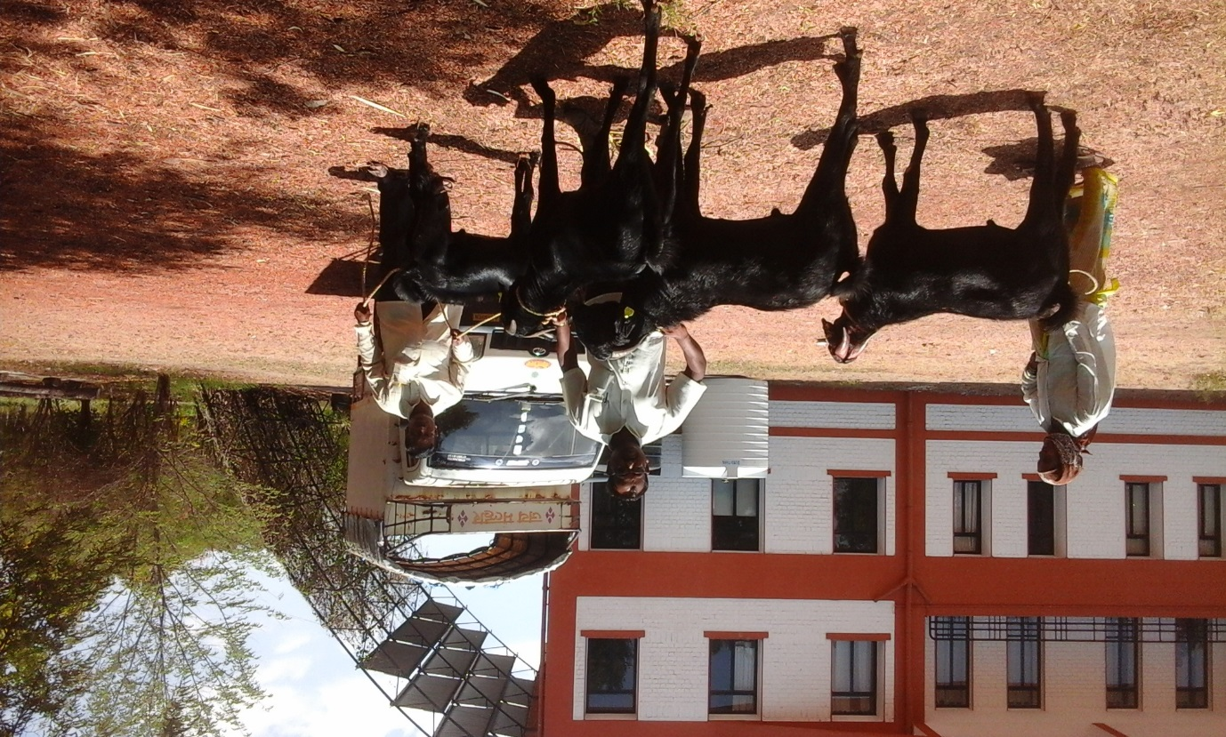
Newly purchased Osmanabadi bucks at NARI

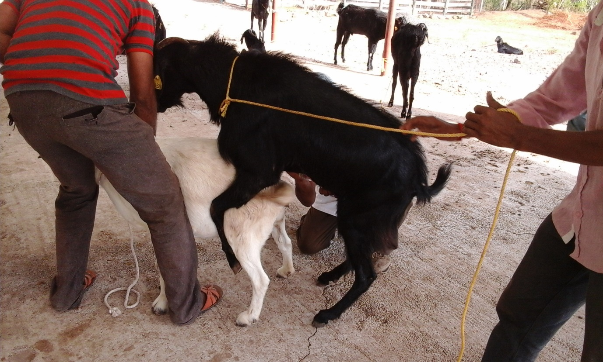
Semen collection of Osmanabadi buck

